Chapter 1
Introduction
1.1 Introduction of the System
In VEHICLE ASSISTANCE NETWORK application, giving your vehicles for service is much easier and reliable when compared to the existing methods. In the proposed system every customer of a showroom will be allocated with the job card where job card contains all the important information related to the service of the vehicle. Here after running the vehicle for certain kilometres as per suggested by the company if the vehicle is in need to service then the customer can use this application to do so. Using this application customer can notify the service centre about the damage occurred to the vehicle, following which the service centre will go through it and can allocate the date and time for the customer for their vehicle to get serviced also they will reveal the date of delivery of the vehicle after service. In some situations, it’s possible that vehicles are more damaged than the service limit and need to be repaired in such situations service centre can reject the service requested by the customer through this application itself, hence service approval or rejection is also included here. This application is a great tool for today’s busy life as it saves lot of time, energy and also is much reliable and efficient.
1.2 Project Title
VEHICLE ASSISTANCE NETWORK
  - Category
Web application and RDBMS
  - Overview
Automated Systems improve efficiency for everyone involved. The Employee Spends less time on paper work and more time monitoring the happening progresses. Record keeping is easier and more accurate.

1.5 Brief note on Existing System
Existing System is paper based recording. It is difficult since if we need particular information we have to move on the pages. Vehicle Assistance Network overcomes the limitation of paper-based recording.
1.6 Objectives of the System
- To help customers in getting timely service to the vehicles.
- To help customers in notifying the service centre about the damage occurred to the vehicle.
- To Reduce the manual work.
- To save time.

  - Scope of The Project
- The purpose of this project is to overcome the drawbacks of traditional method where customer must wait to get the vehicle serviced.
- Here the customer will be notified once the service is due which helps the customer to get timely service.
- This application is a great tool for today’s busy life as it saves lot of time,

  - Structure of the System
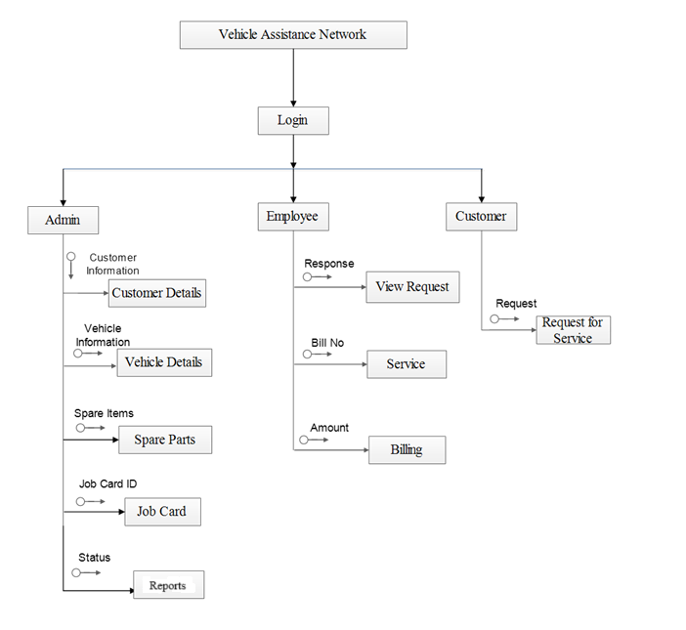
Fig 1.0 System Structure

1.9 System Architecture
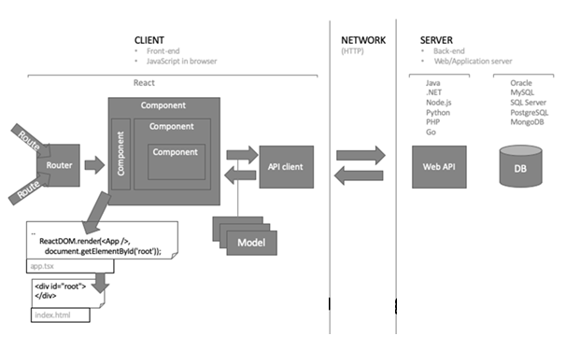
Fig 1.2: Architecture of the system
1.10 End Users
The System is designed with the intension to provide easy to use simple system so that no cumbersome and elaborate training for operation is needed. Admin can add details about customer and employee. The Admin is the main user of the system.
Admin: Admin has all the control over monitoring the vehicle services. He is responsible to allot the appointment to the customers for the service. The admin views various users of the application. He is responsible to do the service due notification. He adds all the customer details and job card details.

1.11 Software/Hardware used for the development
1.11.1 Hardware Requirements:
- RAM: 16GB or above
- SSD: 1TB or above
- Processor:

1.11.2 Software Requirements:
- Back end: My SQL 5.0
- Languages: React, JavaScript, PHP, HTML, CSS
- Frame work: React.js, Express.js
- Operating system: Windows 11
- Server: XAMPP
1.11.3 Software/Hardware required for the implementation
- Operating System: Windows 11
- Hard disk: minimum 16 GB , 1TB RAM
- Visual Studio 2010-version 10.0.30319.1 RTMRel
- Version: MySQL 1.2.12.

Chapter 2
SOFTWARE REQUIREMENT SPECIFICATIONS

2.1 Introduction
The objective of this Software Requirements Specification (SRS) is to formalize and document the client’s vision for the proposed system. This document serves as a detailed blueprint that allows the client to articulate their expectations clearly, ensuring that the development team fully comprehends the necessary features and functionalities required to build the system.
This SRS is intended to guide both developers and testers in the system’s development process. The goals include fully automating the system, minimizing errors, streamlining operations to save time, centralizing database management, enhancing usability for system operators, promoting paperless operations, providing cost-efficient solutions, and delivering an intuitive graphical users interface with context-sensitive help.
2.2 Overall Description
Using this application customer can notify the service centre about the damage occurred to the vehicle, following which the service centre will go through it and can allocate the date and time for the customer for their vehicle to get serviced also they will reveal the date of delivery of the vehicle after service. In some situations, it’s possible that vehicles are more damaged than the service limit and need to be repaired in such situations service centre can reject the service requested by the customer through this application itself, hence service approval or rejection is also included here.
This application is a great tool for today’s busy life as it saves lot of time, energy and also is much reliable and efficient.

2.3 Product Perspective
Product perspective is essentially the relationship of the product to other products, defining if the product is independent or is part of a larger product.
This is a new, self-contained online evaluation of the project in which the system every customer of a showroom will be allocated with the job card where job card contains all the important information related to the service of the vehicle. Using this application customer can notify the service centre about vehicle to be repaired in such situations service centre can accept or reject the service requested by the customer through application itself, hence service approval or rejection is also included here.

2.3.1 Product Functions
- User creation.
- Login.
- Add employee.
- Job card.
- Service.
- Service update.
- Request Service.
- View approval.
- Payment.

2.3.2 User Classes and Characteristics
The system is designed with the intension to provide easy to use simple system so that no cumbersome and elaborate training for operation is needed.
Project evaluation has 3 levels:
Admin:
The Admin plays an important role in the system and handles various responsibilities. The admin does many works such as managing users, vehicles, feedback, and user reports. These tasks help in maintaining the overall workflow and smooth functioning of the application.

Client:
The client adds all the details of the services and also the details of the payment and the information is loaded to the client. They create their accounts with their username and password to access the application.

Employee:
The employee checks all the service problem and the service will be approved or disapproved. Each of them will have their own id and password and they can access the service details.

2.3.3 General constraints
- All the fields or required information has to be provided while registering.
- The application should have a relational database.
- The application shall display error messages to the user when an error is detected.
- It can be reusable and verifiable.
- It supports appropriate changes.

2.3.4 Assumptions
- The system is completely dependent on internet connection.
- The Information provided by the user is assumed to be genuine.
- The activity should be authorized by the admin.
- Every vehicle owner should be registered to use the system.
- The mobile network should be available to receive notifications through SMS.
- The information is maintained safe and secure.

2.3.5 Special Requirements
Not applicable

2.4 Functional Requirements
Functional Requirement specifies which output should be produced for the given inputs. All inputs are entered according to the data type and no blanks are allowed for mandatory fields. Invalid inputs are not allowed in the system. It prompts to re-enter the data. Appropriate error messages are displayed.
- User Creation: In this module Admin gives the username and password to the particular users.
Input : User Name, Password, User Type, Phone number
Output : Authorized page will be displayed.
Processing : If the username and password is incorrect then the error message is displayed.

- Customer Details: This module is used to view the customer details.
Input : Customer ID, Customer Name, Address, Contact Number, E-Mail ID.
Output : Customer details has been entered.
Processing : If the Customer details is invalid then the error message is displayed.

- Job Card: This module contains information about vehicles.
Input : Vehicle Number, Customer ID, Employee name.
Output : Information about vehicles will be displayed.
Processing : If the vehicle is number is invalid then the error message is displayed.
- Vehicle Details: This module is used to store the vehicle details.
Input : Customer id, Vehicle number, Model number, Chassis number, Insurance Number.
Output : Authorized page will be displayed.
Processing: If the details about the vehicle is incorrect the error message is displayed.

- Service: In this module the service information is being displayed.
Input : Service ID, Vehicle Number, Description.
Output : Authorized page will be displayed.
Processing : Service Id must be same.
- Billing: In this module bill is been done.
Input : Bill Number, Service ID, Amount.
Output : Billing is done.
Processing : Service ID must be same.
- Login: In this module, user has to enter the username and password in order to login to the system.
Inputs : Current password, new password, Confirm password.
Output : Authorized page will be display.
2.5 Design Constraints:
- Email field to be entered with text in email format itself.
- Requires to specify the information for all the mandatory fields.
- The application shall have a relational database.
- The application shall be implemented using asp.net MYSQL 5.0, and Microsoft Visual studio 2010.
- The application shall display error messages to the user when an error is detected.

2.6 System attributes
This section of the vehicle assistance network SRS describes the applications attributes and properties.
- Availability: vehicle assistance network shall be available in internet 24x7 and capable of supporting a multiple login.
- Security: vehicle assistance network shall be managed by the administrator via predetermined roles.
- Maintainability: During maintenance stage, the SRS can be referred for the validation
- Portability: Since it is a system, it is portable.
- Timeliness: The system carries out all the operations with consumptions of very less time

Chapter 3
SYSTEM DESIGN

3.1 INTRODUCTION
System design is essentially a bridge between requirement specification and final solution for the requirements. This focuses on deciding which components needed for the system, the specification of those components and how components should be interconnected.
The most challenging and creative system development cycle is system design. The term describes the final system and process by which it is developed. It also includes the construction of the program and program testing the question here is know should be the problem solved? The design is about how to approach compare to analysis. What is orientation? It translates the system requirements in to detailed implementation, the system recommended in the feasibility study.

3.2 ASSUMPTIONS AND CONSTRAINTS
- User must be knowing initial computer operating techniques.
- System is depending on the connection of the internet.
- The required data provided by the operator is assumed to be genuine.

3.3 FUNCTIONAL DECOMPOSITION

3.3.1 System software architecture
The term Software Architecture intuitively denotes the high-level structure of a software system. It can be defined as the set of structures need to understand the software system, defined the software elements, the relations between them, and the properties of both elements and relations.

3.3.2 System technical architecture:
The Web server (IIS 7.0) used to execute SQL query and MYSQL server used to store database records. The project “Lawyers dairy” works under following technical architecture:

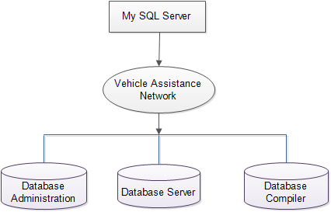
Fig 3.1 System technical architecture

    - System Hardware Architecture
Hardware architecture refers to the identification of a system’s physical components and their interrelationships. this description, often called a hardware model, allows hardware designers to understand how their components fit into system architecture and provides software components designers important information need for software development and integration.

  - DESCRIPTION OF PROGRAMS

3.4.1 Context Flow Diagram (CFD)

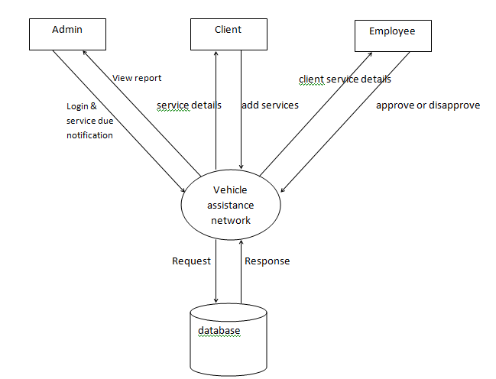
Fig 3.2 Context Flow Diagram

3.4.2 Data Flow Diagram (DFD)
3.4.2.1 DFD FOR ADMIN
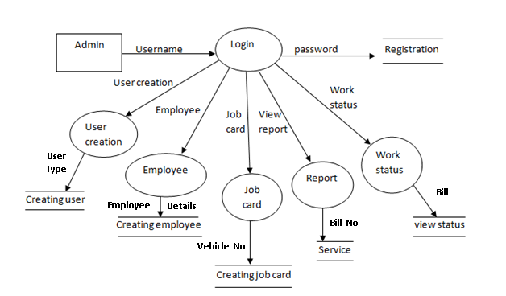
Fig 3.4.2.1 DFD FOR ADMIN
3.4.2.2 DFD FOR EMPLOYEE
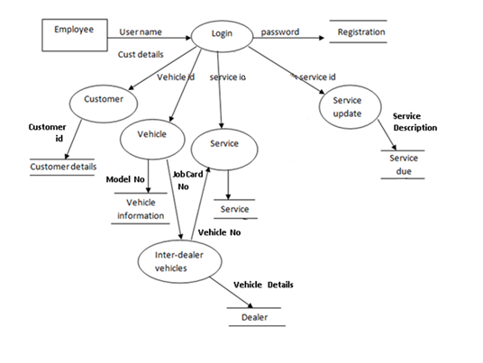
Fig 3.4.2.2 DFD FOR EMPLOYEE
3.4.2.3 DFD FOR CLIENT:
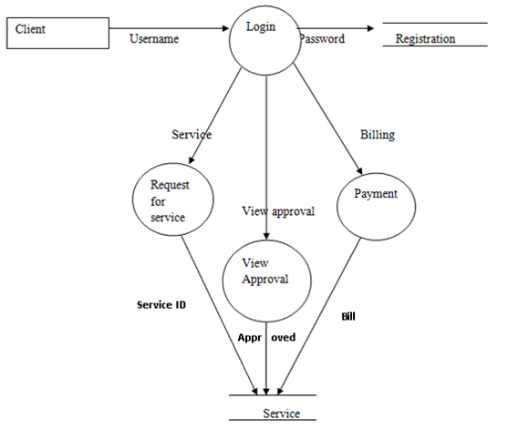
Fig 3.4.2.3 DFD FOR CLIENT
  - Description of Components
3.5.1 User Creation: In this module Admin gives the username and password to the users.
Input : User ID, User Name, Password, User Type.
Output : Authorized page will be displayed.
Processing : If the username and password is incorrect then the error message is displayed.
3.5.2 Customer Details: This module is used to view the customer details.
Input : Customer ID, Customer Name, Address, Contact Number, E-Mail ID.
Output : Customer details has been entered.
Processing : If the Customer details is invalid then the error message is displayed.
3.5.3 Job Card: This module contains information about vehicles.
Input : Vehicle Number, Customer ID, Employee name.
Output : Information about vehicles will be displayed.
Processing : If the vehicle is number is invalid then the error message is displayed.
3.5.4 Vehicle Details: This module is used to store the vehicle details.
Input : Customer id, Vehicle number, Model number, Chassis number, Insurance Number.
Output : Authorized page will be displayed.
Processing : If the details about the vehicle is incorrect the error message is displayed.
3.5.5 Service: In this module the service information is being displayed.
Input : Service ID, Vehicle Number, Description.
Output : Authorized page will be displayed.
Processing : Service Id must be same.
3.5.6 Billing: In this module bill is been done.
Input : Bill Number, Service ID, Amount.
Output : Billing is done.
Processing : Service ID must be same.
3.5.7 Login: In this module, user has to enter the username and password in order to login to the system.
Inputs : Current password, new password, Confirm password.
Output : Authorized page will be display.

CHAPTER 4
DATABASE DESIGN
4.1 INTRODUCTION
Database Design is a collection of processes that facilitate the designing, development, implementation and maintenance of enterprise data management systems. The main objectives of database designing are to produce logical and physical designs models of the proposed database system. The logical model concentrates on the data requirements and the data to be stored independent of physical considerations. It does not concern itself with how the data will be stored or where it will be stored physically.
4.2 PURPOSE AND SCOPE
Organizations use large amounts of data. A database management system (DBMS) is a software tool that makes it possible to organize data in a database. The database in turn is further described in detail giving all the fields used with their data type, constraints available to them and description. Constraints include primary key, foreign key, etc., which allow the entities to be uniquely identified.

4.3 DATABASE IDENTIFICATION
- Database table name and column names are defined without leaving space.
- Lower case is used to create table and column names.
- Primary key and foreign key are define using the same name.
4.4 SCHEMA INFORMATION
4.4.1 Description
The description of the database is called database schema. A database schema is specified during database creation and is not accepted to change frequently. Most data model has certain conversation for diagrammatically displaying schema. The schema diagram displays only some aspects of schema, such accepts are not specified in the diagram that is neither the data type of each data item that changed frequently. The data in the database moment in timer is called a database state.
4.5 TABLE DEFINITION

CUSTOMER_DETAILS
Customer_ID | Customer_Name | Address | Contact_No | Email_id

JobCardID | Vehicle_No | Customer  _Name | Employee  _Name | Problem | JobCardNo | Date | Delivery_date | subdate
JOBCARD

REGISTRATION
Reg_id | Username | Password | usertype | phone | Email | Salary

REQUEST_FOR_SERVICE
Service_Approval_ID | Vehicle_No | Registered_Date | Problem | Submission_Date | JobCardNO

SERVICE
Service_ID | Bill_No | JobCard_No | vehicle_no | customer_name | Adderss | phone | Problem | delv_date
service_amt | Price | total | Net

VEHICLE_DETAILS
Vehicle_ID | Customer_name | Vehicle_Number | Model_Number | Insurance_Number | vehicle_type

4.6 Physical Design
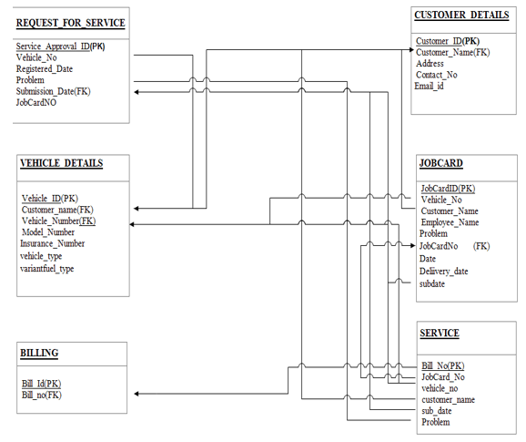
`Fig 4.6 Physical Design

4.7 Data Dictionary
Registration:
Vehicle-Details
Attribute | Datatype | Constraints
Vehicle_ID | INTEGER | Primary key
Customer_ID | VARCHAR(10) | Not Null
Vehicle_Number | VARCHAR(10) | Not Null
Model_Number | VARCHAR(20) | Not Null
Insurance_Number | VARCHAR(20) | Not Null
Table:4.1 Vehicle-Details
Job Card
Attribute | Datatype | Constraints
JobCardID | INTEGER | Primary key
VehicleNo | VARCHAR(10) | Not Null
CustomerName | VARCHAR(25) | Not Null
EmployeeName | VARCHAR(25) | Not Null
Problem | VARCHAR(45) | Not Null
Table: 4.2 Job Card

Service
Attribute | Datatype | Constraints
Service_ID | INTEGER | Primary key
Bill_No | VARCHAR(10) | Not Null
Vehicle_No | VARCHAR(10) | Not Null
Customer_Name | VARCHAR(25) | Not Null
Employee_Name | VARCHAR(25) | Not Null
Jobcard_No | VARCHAR(10) | Not Null
Amount | VARCHAR(10) | Not Null
Description | VARCHAR(25) | Not Null
Problem | VARCHAR(45) | Not Null
No of Days | VARCHAR(10) | Not Null
Approval | VARCHAR(25) | Not Null
Table:4.3 Service

Request for service
Attribute | Datatype | Constraints
Service_approvalID | INTEGER | Primary key
Jobcard_No | VARCHAR(10) | Not Null
Vehicle_No | VARCHAR(10) | Not Null
Customer_Name | VARCHAR(25) | Not Null
Date | VARCHAR(10) | Not Null
Approved | VARCHAR(25) | Not Null
Table:4.4 Request for service

Billing
Attribute | Datatype | Constraints
Bill_No | INTEGER | Primary key
Service_id | VARCHAR(10) | Not Null
Date | VARCHAR(10) | Not Null
Amount | VARCHAR(10) | Not Null
Description | VARCHAR(35) | Not Null
Table:4.5 Billing

4.8 ER DIAGRAM

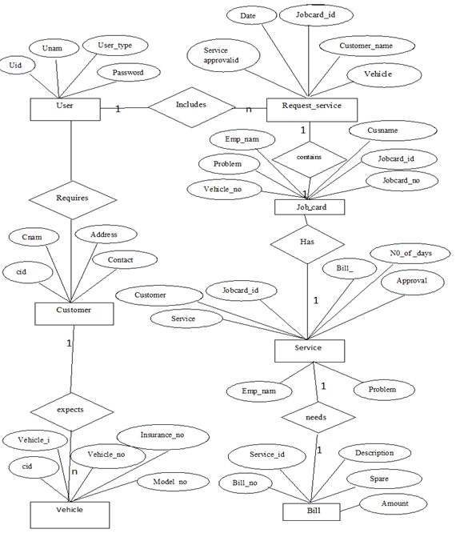

Fig 4.2 ER DIAGRAM
4.9 DATABASE ADMINISTRATION
4.9.1 SYSTEM INFORMATION
- Frontend: visual studio 2010
- Backend: Mysql 5.0
- Language: React
- Framework: Expresss React
- Server: IIS 7.0
- Operating system: windows 11

4.9.2 DBMS CONFIGURTAION
The Ingres client-server architecture allows multiple users access to databases through connections to one or more DBMS Server processes. The DBMS Server is a multi-threaded daemon process that performs asynchronous disk input and output. The number of users connected to a server is limited by hardware or the operating system. A DBA must be able to think logically to solve all the problems and easily work in a team.
    - SUPPORT SOFTWARE REQUIRED:
The system installs MYSQL while installing visual studio 2010.All the backup contents are stored in MYSQL database.
    - Storage Requirements
- The Storage engine represent the heart of a MySQL Server
- Recovering the database from system failure
- Management of files and database pages used to store data
- Manage data buffers and system IO to the physical data pages
- Manage locking and concurrency issues

    - Backup and Recovery
Backup and recovery refers to the process of backing up data in case of loss and setting up system that allows the data recovery due to data loss Backing up data requires copying and achieving computer data, so that accessible in case of data deletion or corruption. The trade-off is that, at recovery time you cannot restore your data just by reloading the full backup. You must also process the incremental backups to recovery the incremental changes. Each time it restarts, the MYSQL server create a new binary log file using the next number in the sequence.

Chapter 5
DETAILED DESIGN
5.1 Introduction
Detailed design starts after the system design phase and system has been certified through the review. The goal of this phase is to develop the internal logic of each of the modules identified during system design.
In the system design, the focus is on identifying the modules, whereas during detailed design the focus is on designing the logic for the modules. In other words, in system design attention is on what components are needed, while in the detailed design how the components can be implemented in the software is the issue.
The design process for software system has two eves. At the first level focus is on deciding which modules are needed for the system, the specification of these modules and how the modules should be interconnected. This is called system design or top-level design. In the specification of the module can be satisfied is decided. This design level is often called detailed design or logic design.
Because the detailed design is extension of system design, system design controls the major structural characteristics of the system. The system design has a major impact testability and modifiability of a system and impacts its efficiency much of the design efforts for the designing software are spent creating the system design.

5.2 Structure of Software Package
The functional components identified during the system design are listed here:
Functional Component 1: Employee
Functional Component 2: Job Card
Functional Component 3: Customer Details
Functional Component 4: Service
Functional Component 5: Vehicle Details
Functional Component 6: Request for Service
Functional Component 7: Billing

5.2.1 Structure chart of the system
5.2.1.1 Admin module
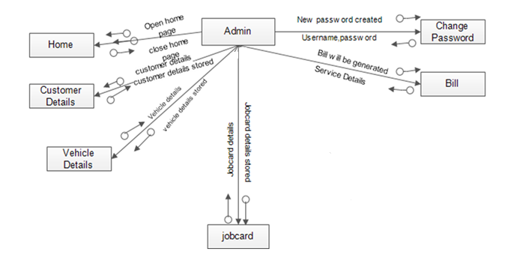
Fig 5.1 Admin module
5.2.1.2 Employee module
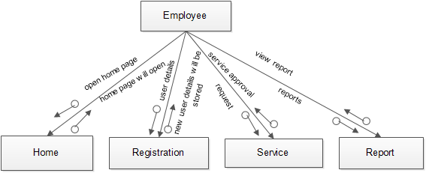
Fig 5.2 Employee module

5.3 Modular decomposition of the System
5.3.1 Module 1: Employee
Input: User ID, User Name, Password, User Type

Procedural Details (Flow Chart)
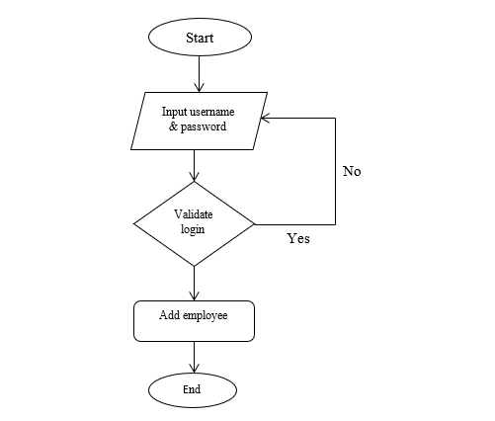

Fig 5.3 Structure Chart for Employee

File I/O: Employee
Output: Authorized page will be displayed.

5.3.2 Module 2: Job Card
Input: Vehicle Number, Customer ID, Employee name

Procedural Details (Flow Chart)
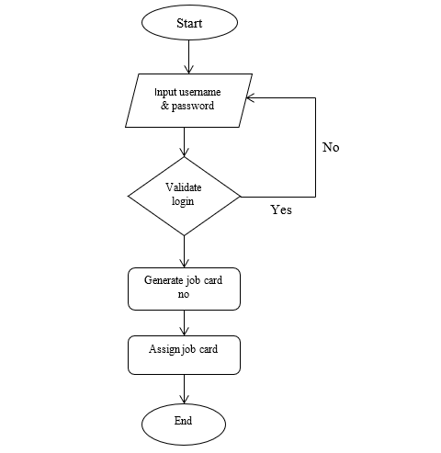

Fig 5.4 Structure Chart for Job Card

File I/O: Job Card, Vehicle Details, Customer Details
Output: Information about vehicles will be displayed.

5.3.3 Module 3: customer Details
Input: Customer ID, Customer Name, Address, Contact Number, E-Mail ID

Procedural Details (Flow Chart)
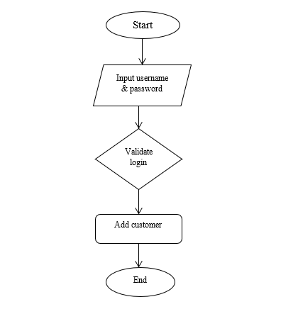

Fig 5.5 Structure Chart for customer Details

File I/O: customer Details
Output: Customer details is been entered.

5.3.4 Module 4: Service
Input: Service ID, Vehicle Number, Description
Procedural Details (Flow Chart)
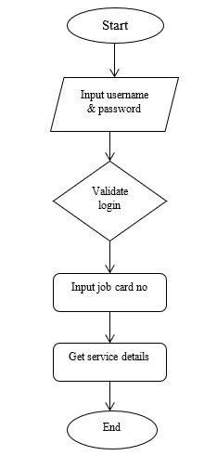

Fig 5.6 Structure Chart for Service

File I/O: Service, Vehicle Details, Customer Details, Job Card
Output: Authorized page will be displayed.

5.3.5 Module 5: Vehicle Details
Input: Customer id, Vehicle number, Model number, Chassis number, Insurance Number

Procedural Details (Flow Chart)
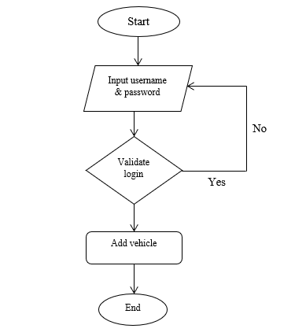

Fig 5.7 Structure Chart for vehicle Details

File I/O: Vehicle Details
Output: Authorized page will be displayed.

5.3.6 Module 6: Request for Service
Input: Service_Approval_ID, JobCard_No, Vehicle_No, Customer_Name, Date, Approved
Procedural Details (Flow Chart)

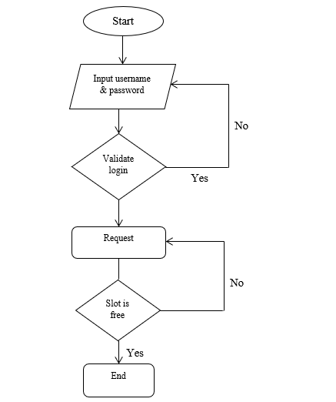
Fig 5.8 Structure Chart for Request for Service

File I/O: Request For Service,Job Card,Vehicle Details,Customer Details
Output: Service status should be displayed
5.3.8 Module 8: Billing
Input: Bill Number, Service ID, Amount

Procedural Details (Flow Chart)
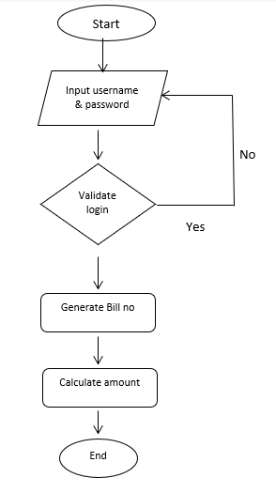

Fig 5.10 Structure Chart for Billing
File I/O: Billing, Service
Output: Billing is done.

CHAPTER 6
IMPLEMENTION
As part of my internship, I was involved in building some of the important modules for the Vehicle Assistance Network. The frontend was developed using React JS and styled with Material UI, while MySQL was used to store and manage the application's data.
8.1 MODULES I WORKED ON:
Admin Side:
- AddUser:
The Add User module enables admins to create accounts for clients and employees, assigning unique usernames, passwords, and user types (Client or Employee). I developed a clean form interface using React JS and Material UI components (e.g., TextField, Button), ensuring a professional look and feel. The module uses JavaScript to handle form submissions and API calls to store user data in the MySQL database, with validation to prevent duplicate usernames or invalid inputs, ensuring secure and efficient user management.
- AddVehicle:
In the Add Vehicle module, admins can register vehicle details, including Vehicle ID, Customer Name, Vehicle Number, Model Number, and Insurance Number. I created a form-based interface with Material UI’s Grid and Table components, displaying vehicle data in a structured format. JavaScript was used to manage state with React hooks (useState, useEffect) and integrate with MySQL via API calls for data storage and validation, preventing errors like duplicate vehicle numbers.
- ManageFeedback:
The Manage Feedback module allows admins to view, respond to, and delete client feedback. I built a responsive table interface using Material UI’s DataGrid, displaying Feedback ID, Customer Name, and Comments with action buttons for management. JavaScript handled API requests to fetch and update feedback records in the MySQL database, with real-time UI updates using React hooks for a seamless admin experience.

- Reports:
The Reports module enables admins to generate insights on service requests, job cards, and feedback. I developed an interface using React JS and Material UI, featuring tables and charts (e.g., via Chart.js) with filtering options by date or customer. JavaScript managed data fetching from MySQL via APIs, with backend SQL queries aggregating data for performance metrics and customer satisfaction reports, supporting informed decision-making.
User (Client) Side:
- RequestService:
The Request Service module allows clients to submit vehicle service requests with details like Vehicle Number, Problem Description, and Submission Date. I created a user-friendly form using Material UI’s TextField and Button components, styled for clarity. JavaScript and React hooks handled form validation and API calls to store requests in the MySQL database, sending notifications to the service center for approval or rejection, with a confirmation message displayed upon submission.
- ViewStatus:
In the View Status module, clients can check the approval status of their service requests, including Service Approval ID, Job Card Number, and Approval Status (Approved/Rejected). I developed a card-based layout using Material UI’s Card component, with data fetched from MySQL via JavaScript API calls. React hooks ensured real-time status updates, providing a responsive and interactive experience for clients.
- Feedback:
The Feedback module enables clients to submit feedback on their service experience, including comments and ratings. I built a form interface with Material UI’s TextField and Rating components, ensuring a visually appealing design. JavaScript managed form submissions and API integration with MySQL, with client-side validation to prevent empty or invalid entries, enhancing user engagement with a confirmation message upon submission.

Employee Side:
- ViewService:
The View Service module allows employees to review service requests, including Service ID, Vehicle Number, and Problem Description. I created a table interface using Material UI’s DataGrid, with JavaScript fetching data from MySQL via APIs. The module supports approving or rejecting requests, with React hooks managing real-time UI updates and ensuring a seamless experience for employees.
- JobCard:
In the Job Card module, employees can view and manage job card details, including Vehicle Number, Customer ID, Employee Name, and Problem. I developed a responsive table interface using Material UI, with JavaScript handling API calls to MySQL for data retrieval and updates. The module ensures efficient service tracking with validation for consistent job card data.
- ViewFeedback:
The View Feedback module enables employees to review client feedback related to their services. I built a table interface with Material UI’s DataGrid, displaying Feedback ID and Comments, sortable by date or customer. JavaScript managed data fetching from MySQL, with React hooks ensuring a responsive and intuitive interface for employees to assess service quality.
- Settings:
The Settings module allows employees to update their account details, such as passwords or contact information. I developed a form interface with Material UI’s TextField and Button components, with JavaScript handling validation for inputs like Current Password, New Password, and Confirm Password. The module integrates with MySQL via APIs to securely update employee records, with error handling for invalid inputs.

CHAPTER 7
TOOLS AND TECHNOLOGIES USED
While developing the Vehicle Assistance Network , I worked with a variety of programming languages, frameworks, and tools that made the development process smoother and more organized. Below are the key technologies and tools I used during the project:
1. Programming Languages
- JavaScript: JavaScript was the primary language used for writing the frontend logic of the application. It helped me create interactive pages and handle user actions effectively.
- SQL: I used SQL for handling database operations in MySQL. It helped in storing, updating, and retrieving data like user details, menu items, orders, and wallet balances.

2. Frameworks and Libraries
- React JS:

React JS was used to build the frontend of the application. Its component-based approach made it easier to create reusable parts of the UI and manage data within the application using state and hooks.
- Material UI:

For designing the user interface, I used Material UI. It provided a wide range of ready-to-use components, which made the frontend look clean and modern without having to write too much custom CSS.

3. Development Tools
- Visual Studio Code (VS Code):
VS Code was my go-to code editor throughout the project. Its useful extensions and features like auto-suggestions and debugging tools made development more efficient.

- MySQL Workbench:
To interact with the database, I used MySQL Workbench. It provided an easy way to manage tables, run SQL queries, and check the data stored.

- Postman:
Postman was handy for testing APIs (wherever backend interactions were needed). It allowed me to verify that the data being sent and received between the frontend and database was accurate.
These tools and technologies played a big role in helping me build a functional, organized, and user-friendly Vehicle Assistance Network

CHAPTER 8
SCREENSHOTS
Register/Login Page:
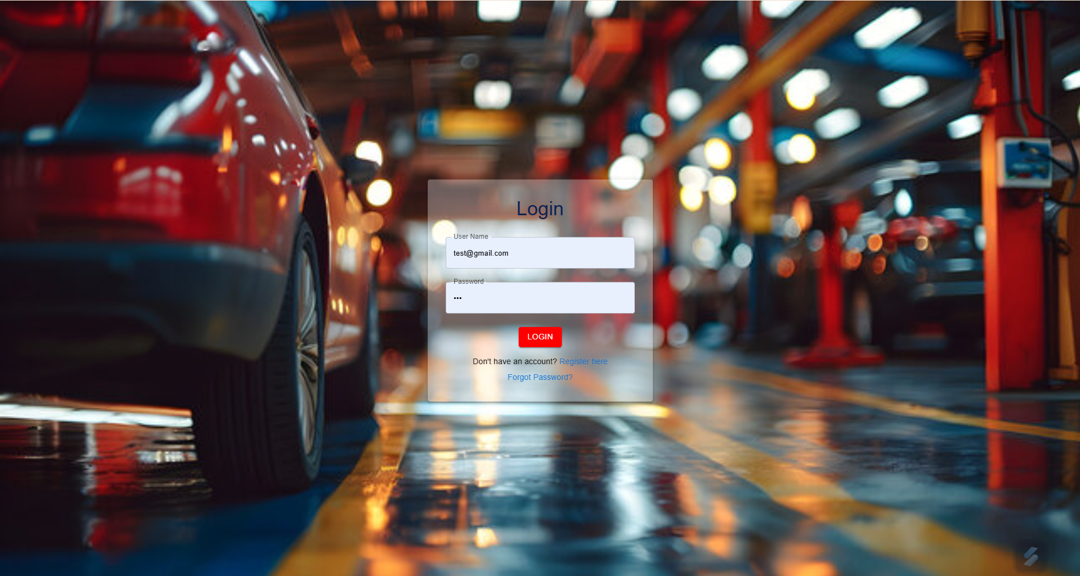
Home page:
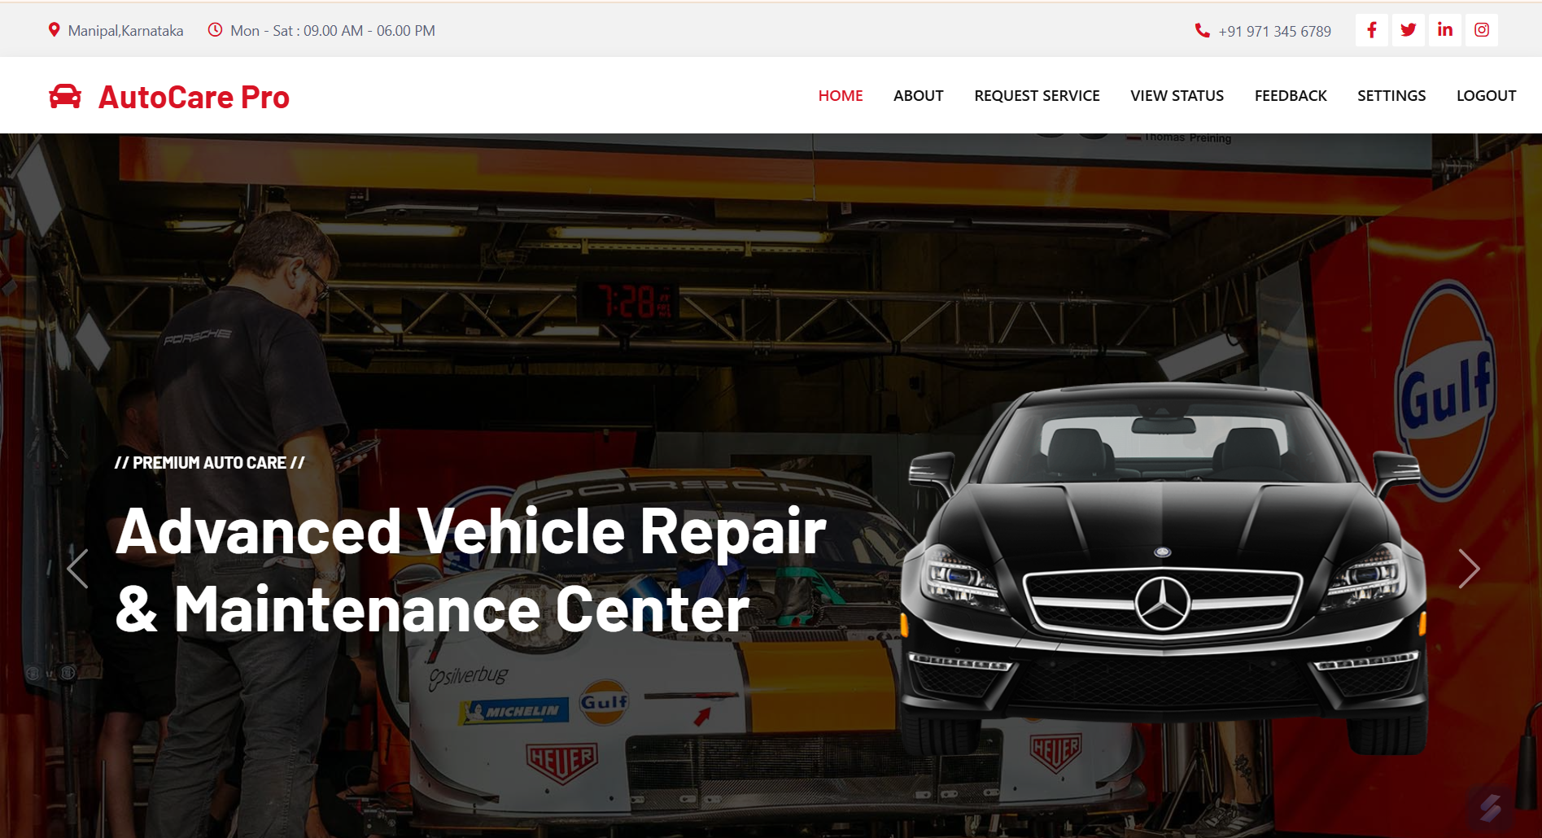


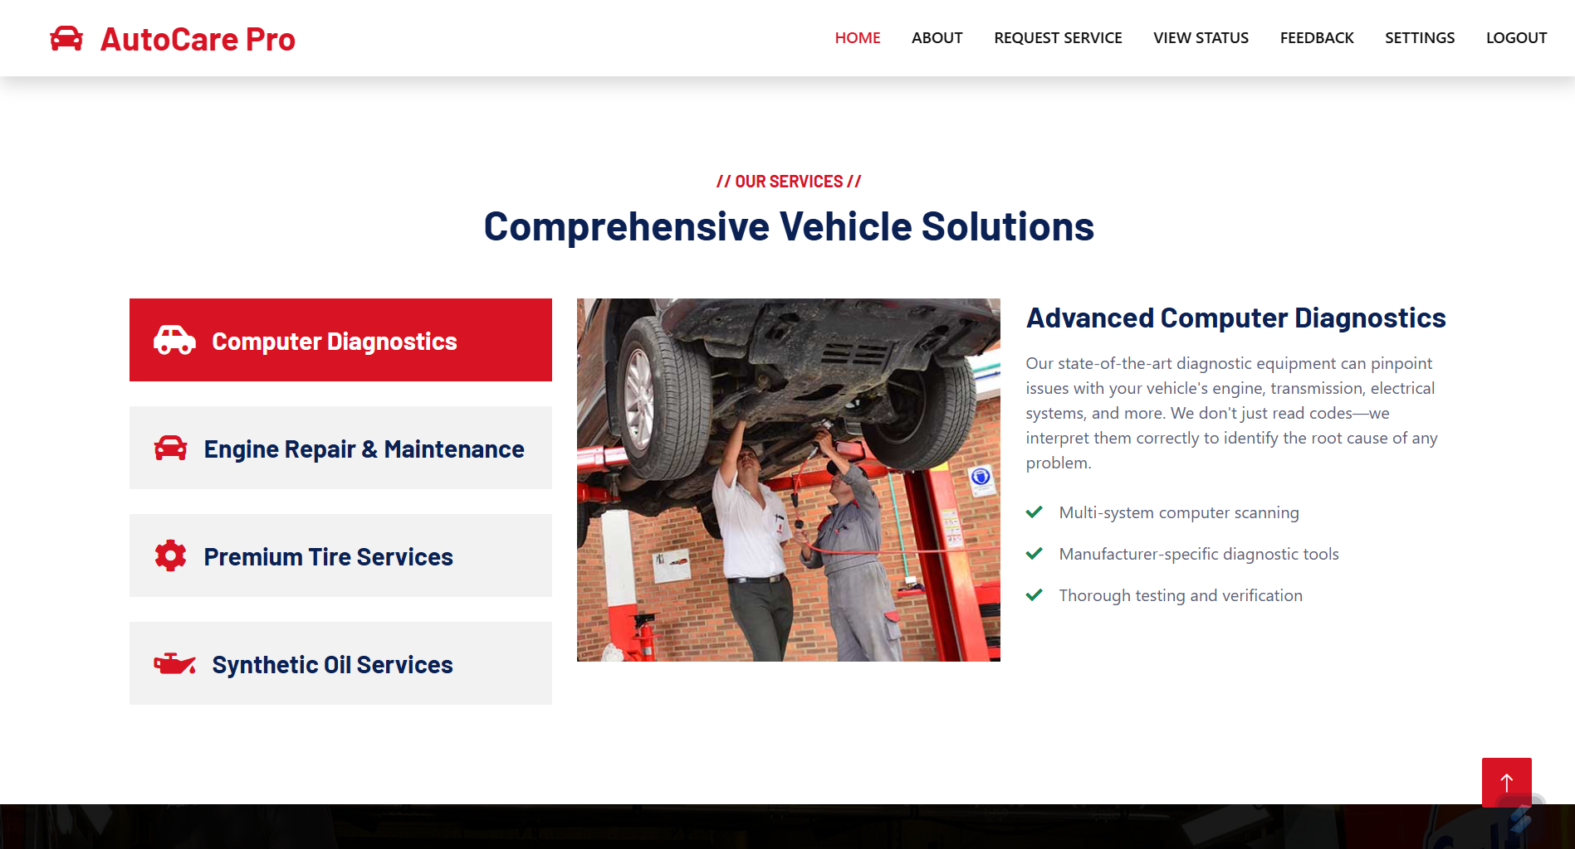

Request Service:
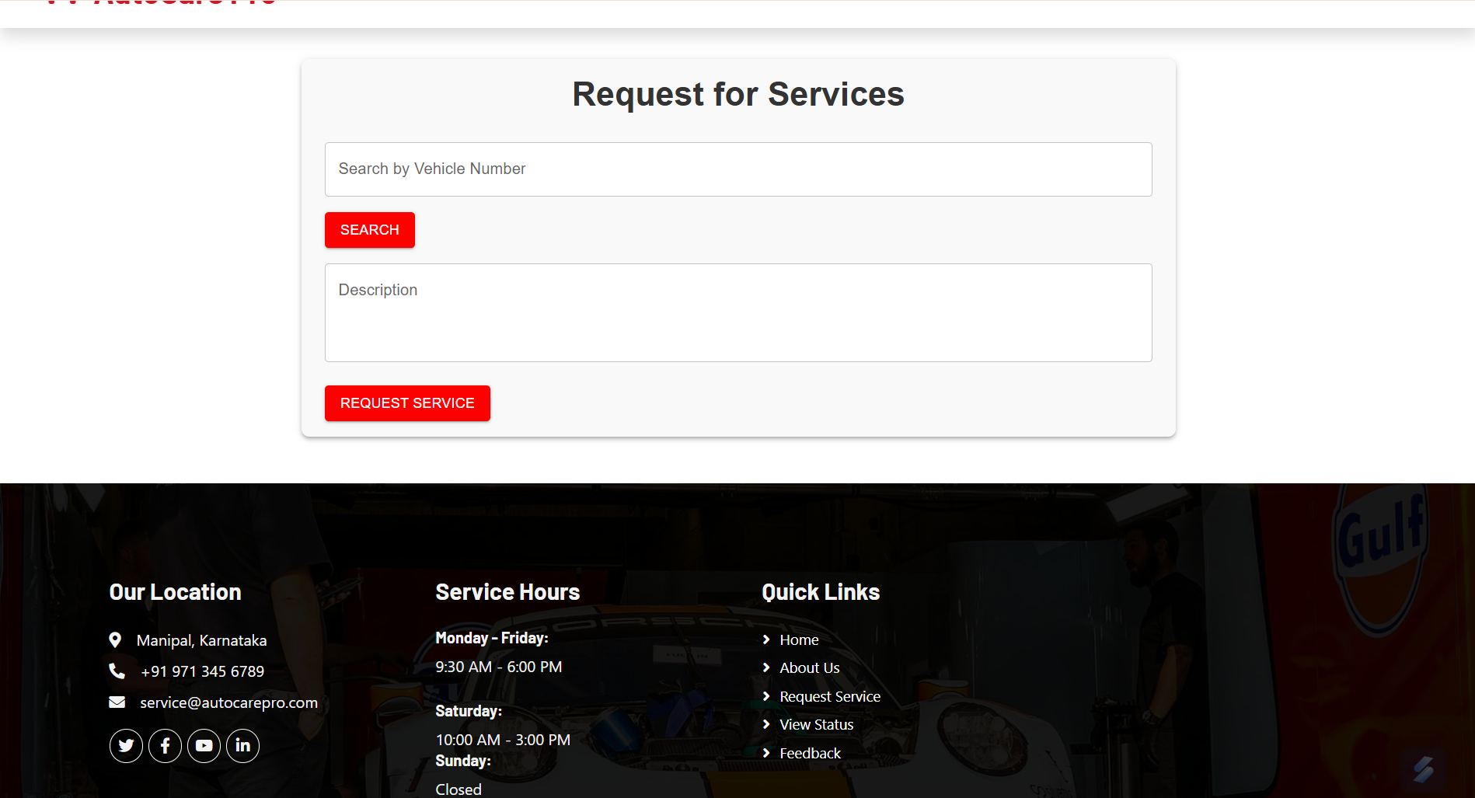
Feedback:
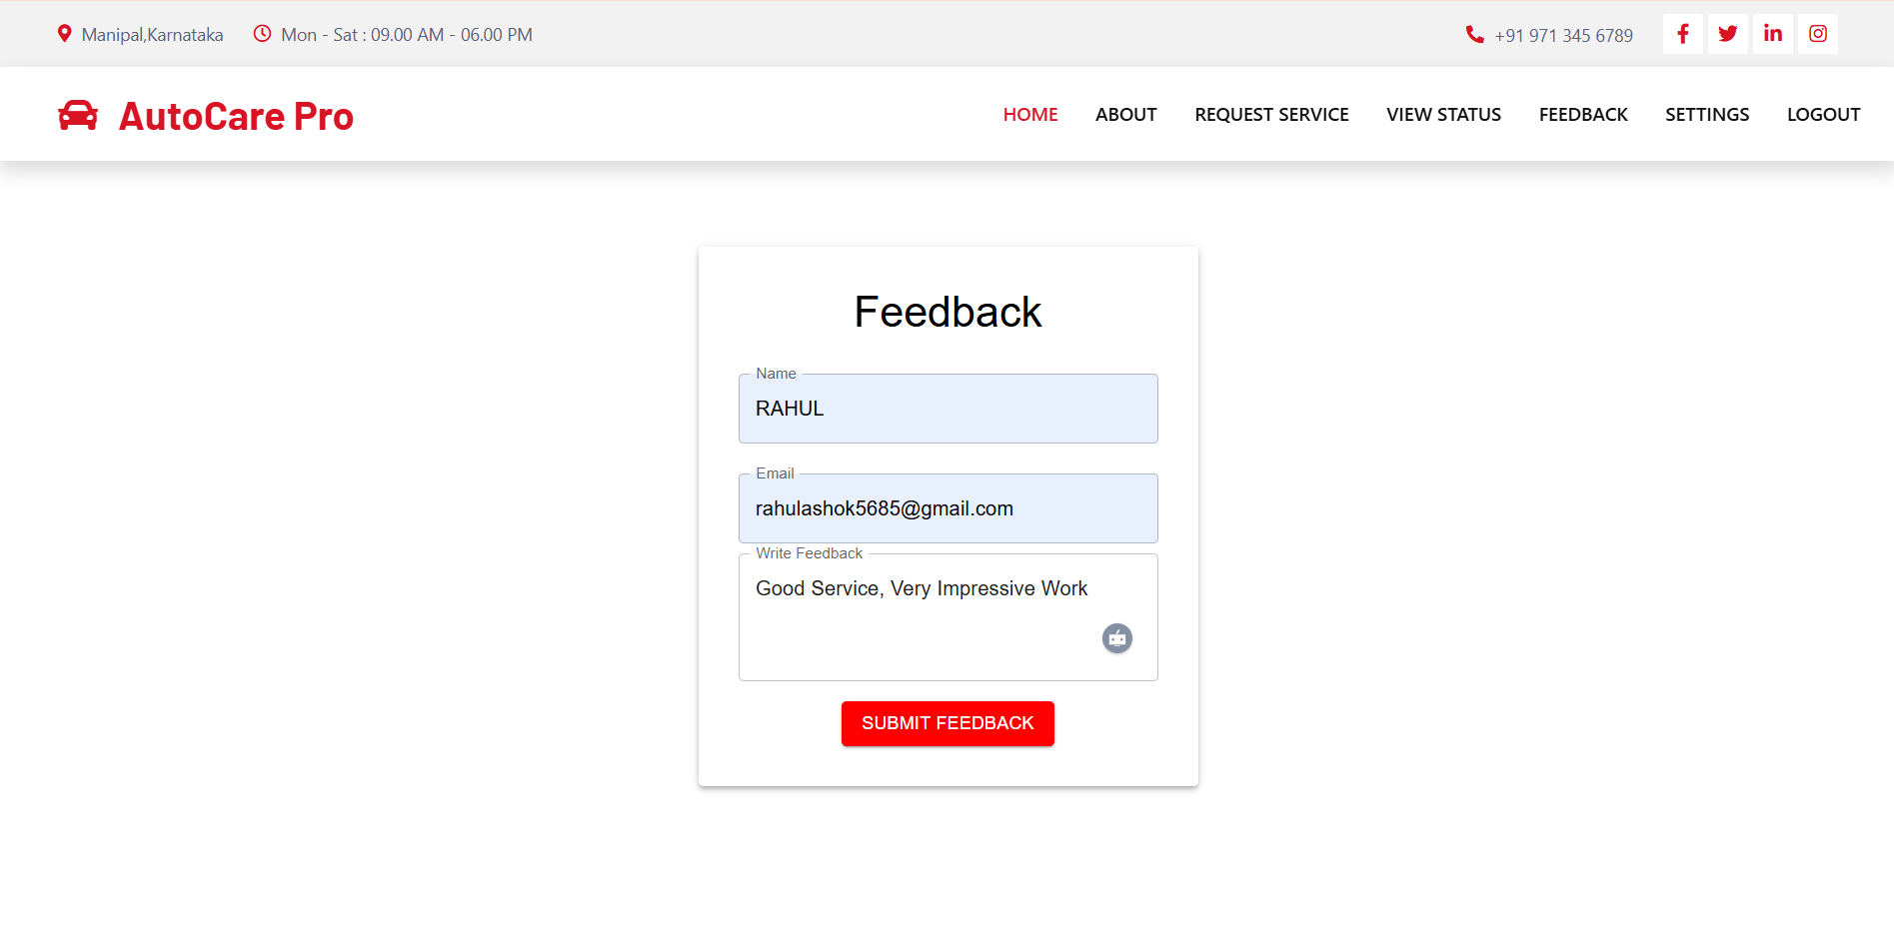
Settings:
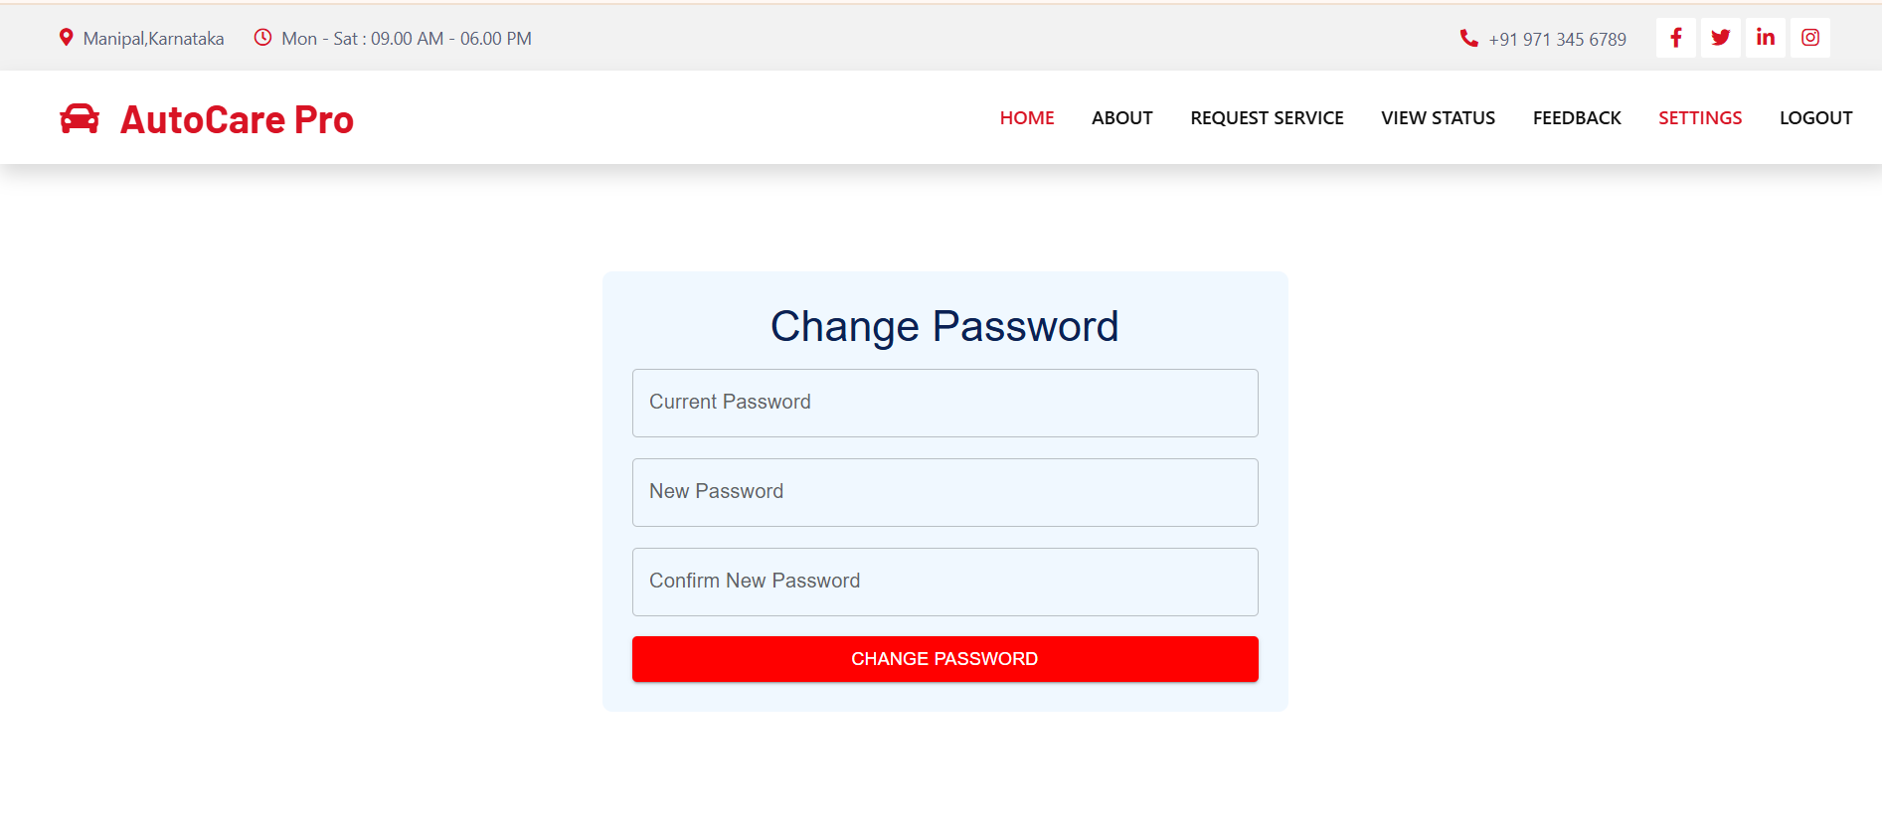

Employee Dashboard:
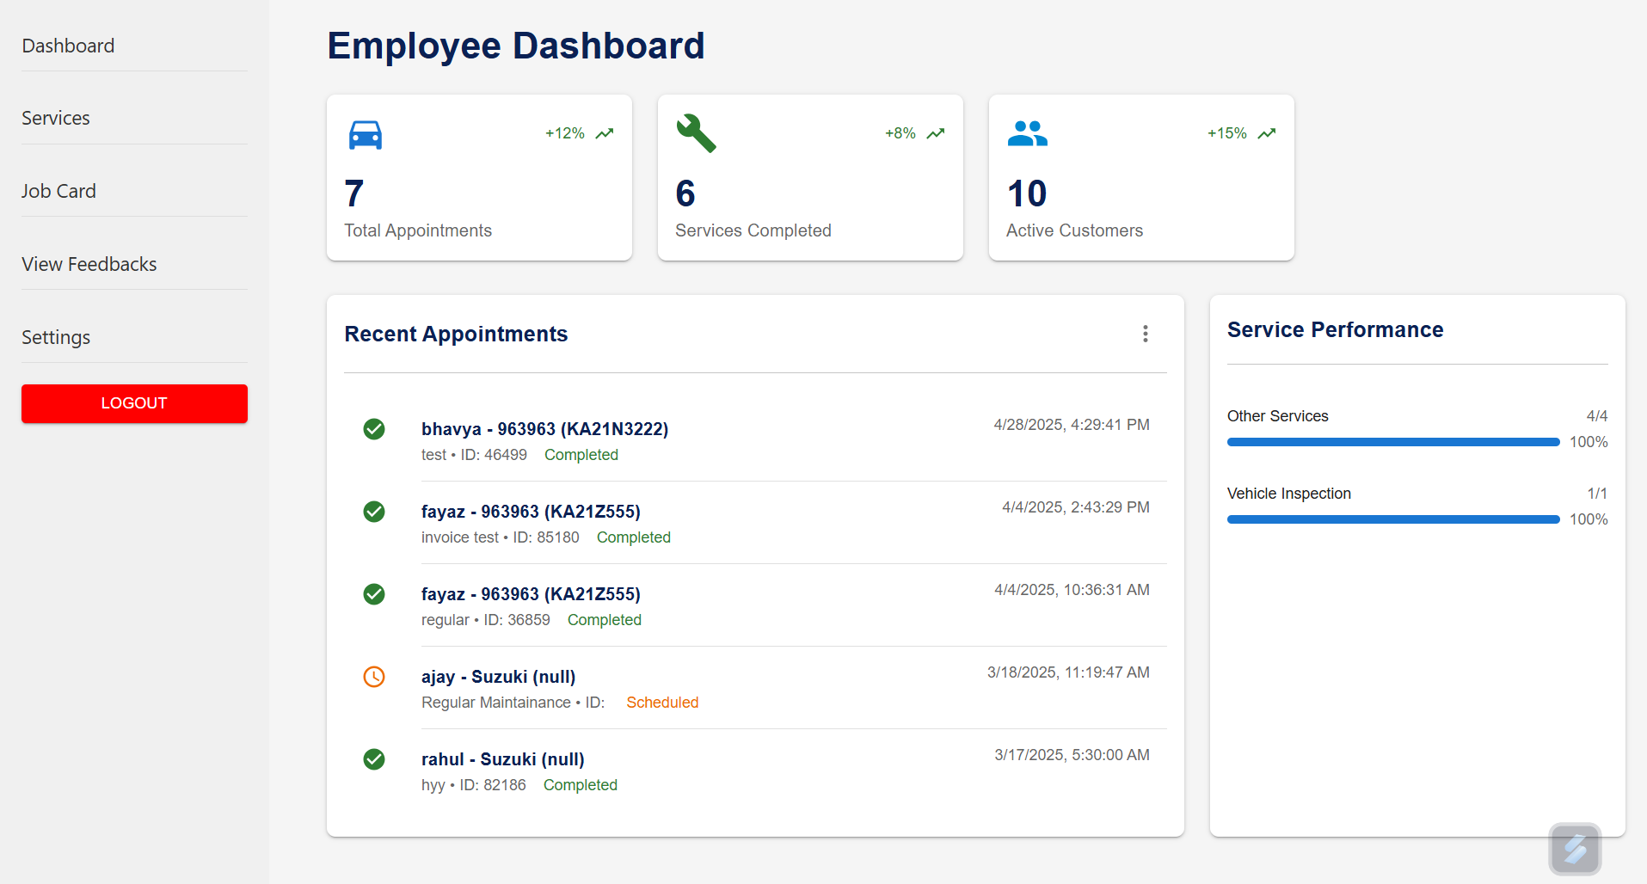

Service:
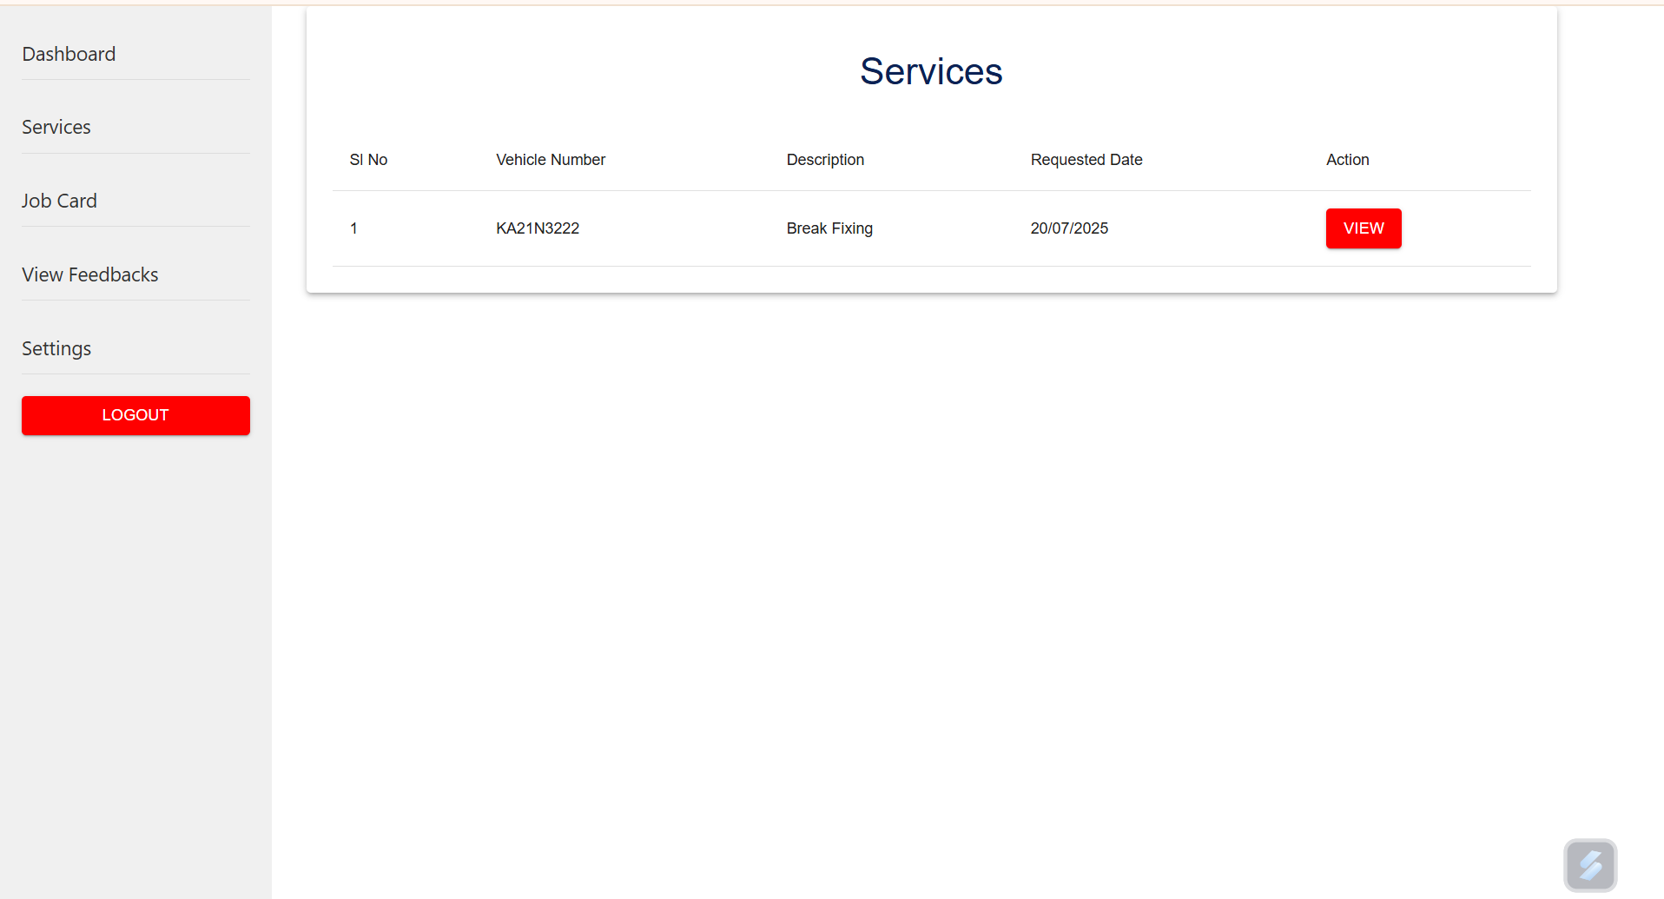
Jobcard:
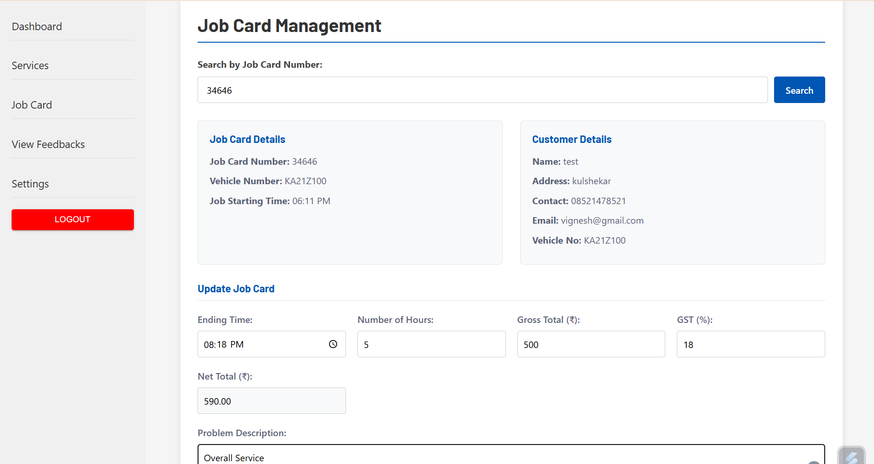

View Feedback:
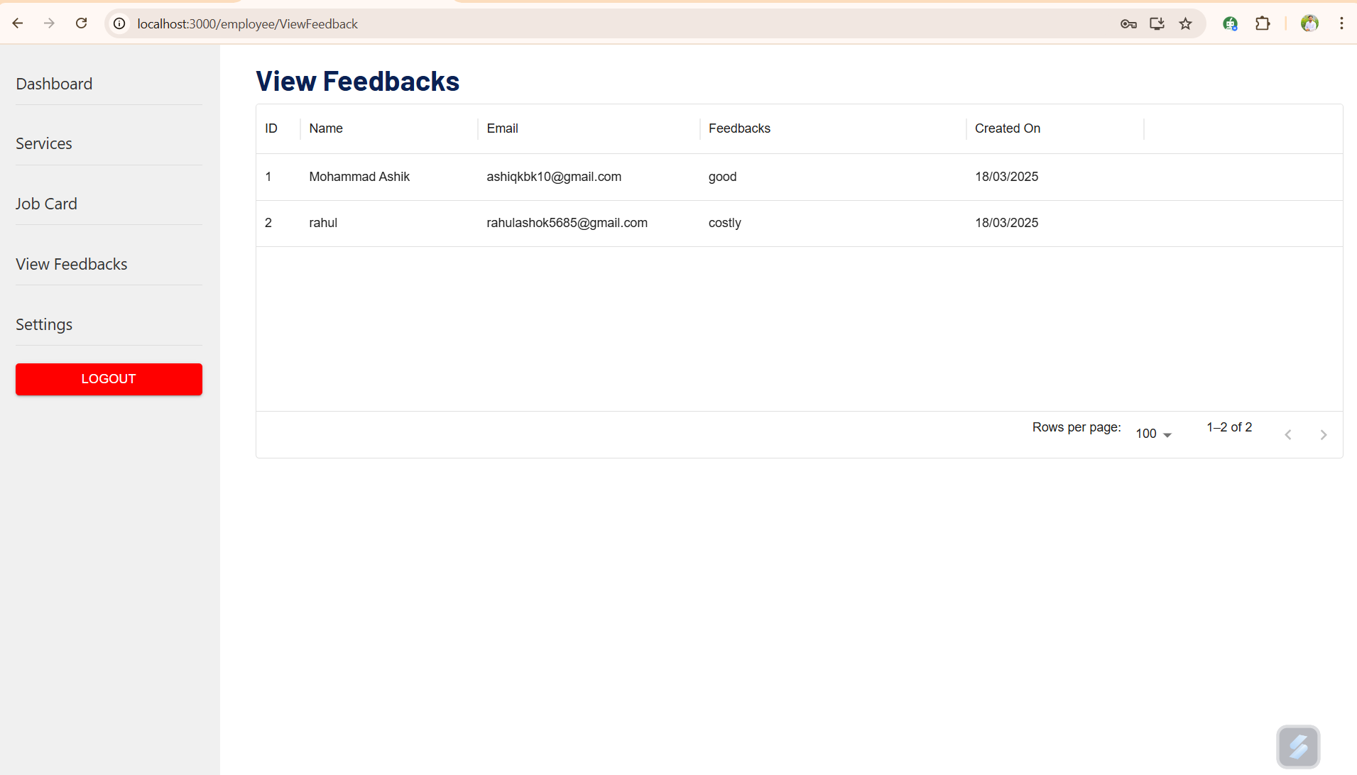

Settings:
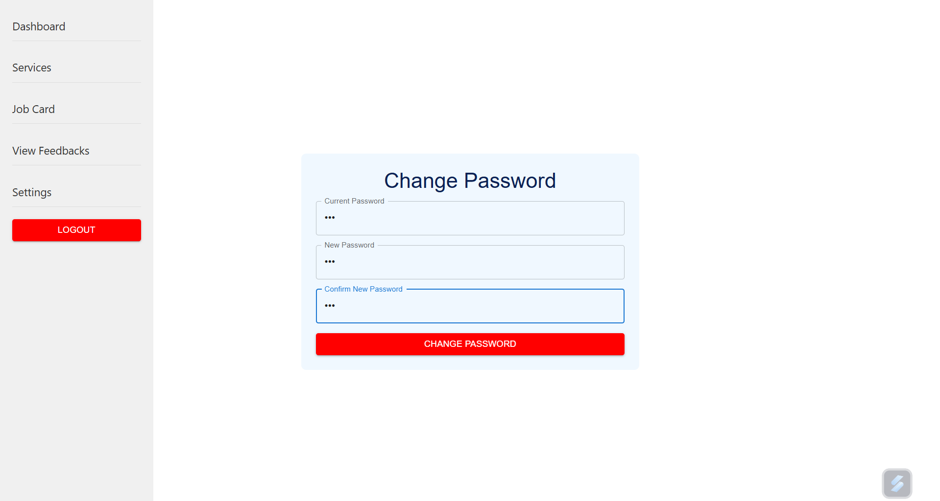

Admin Dashboard:
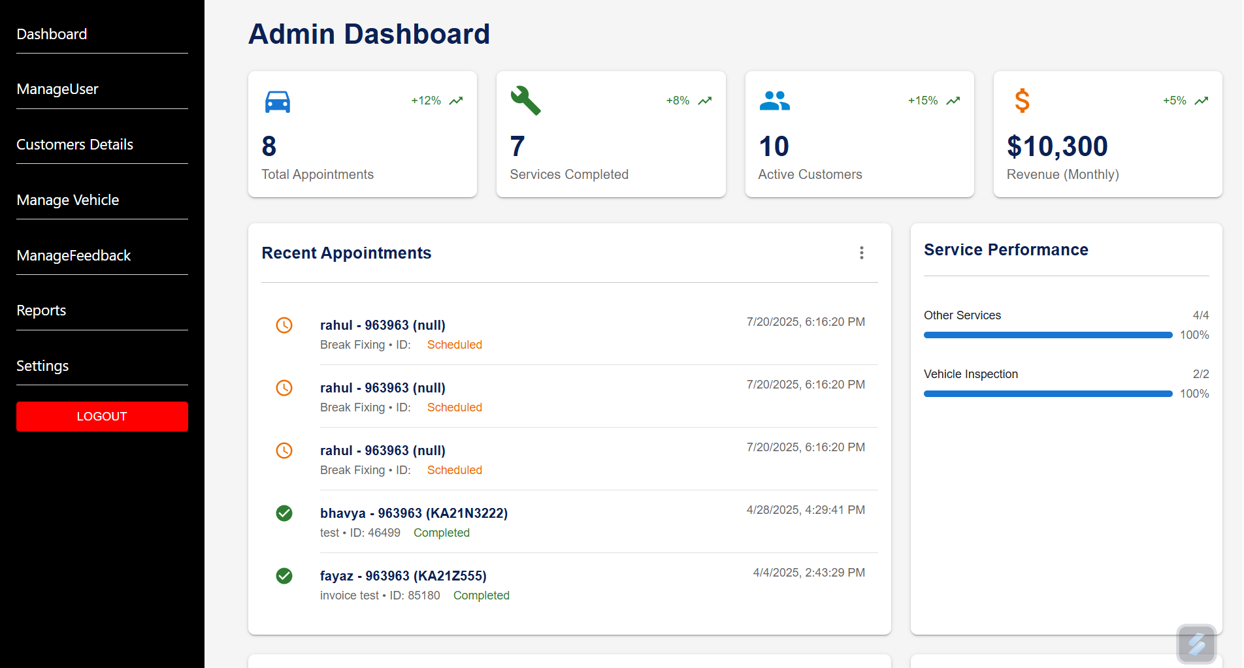
Manage User:
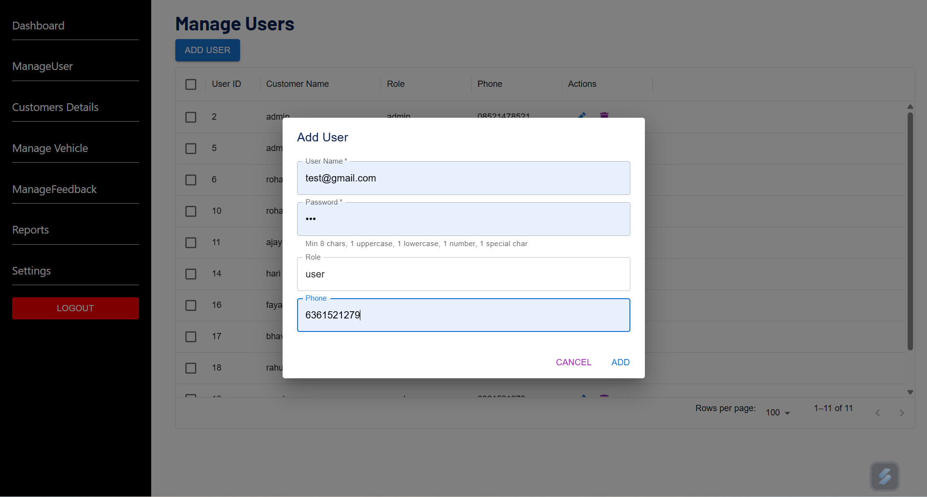

Add Customer:
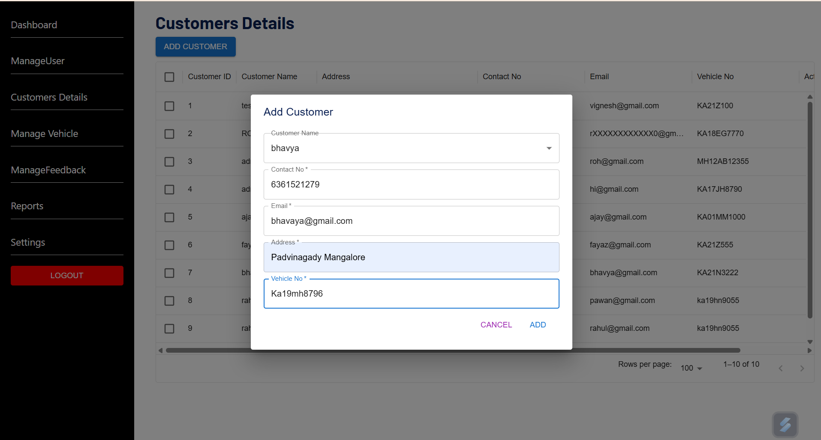
Manage Vehicle:
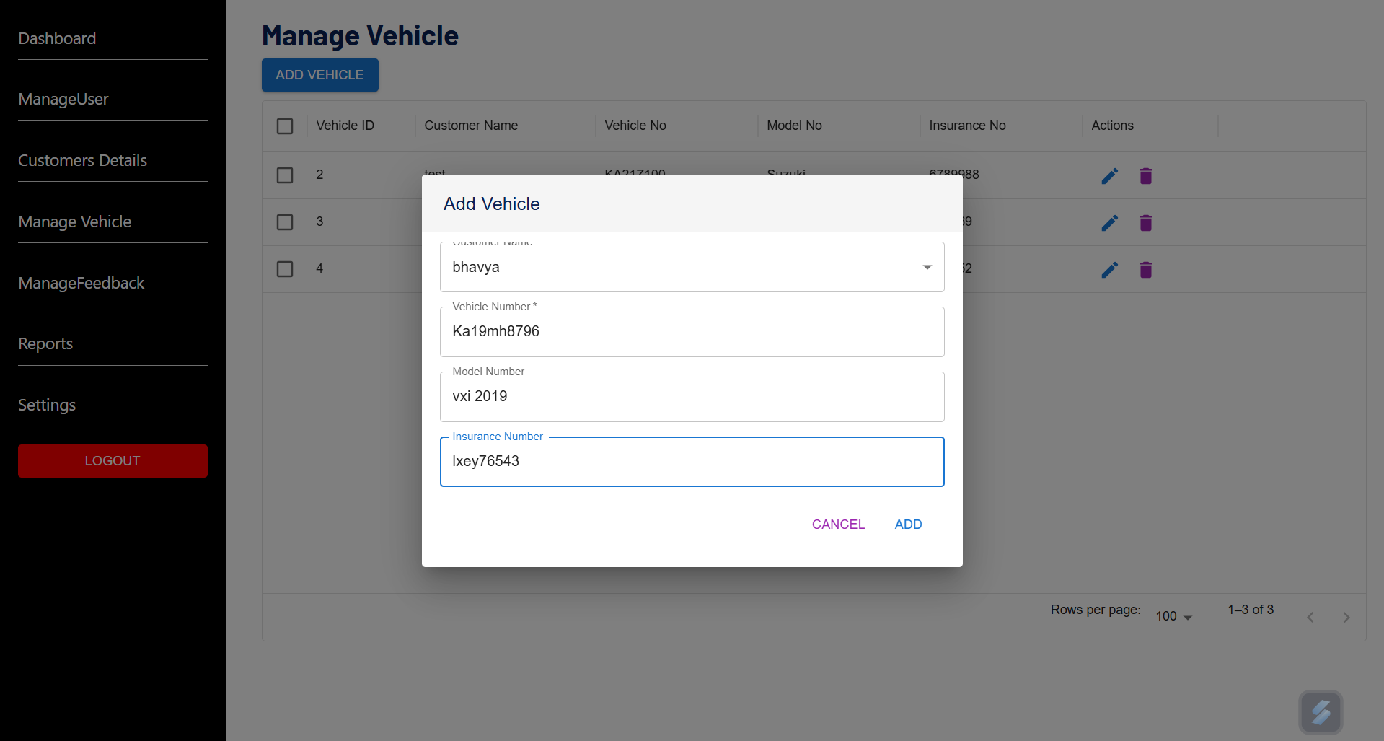

Manage Feedback:
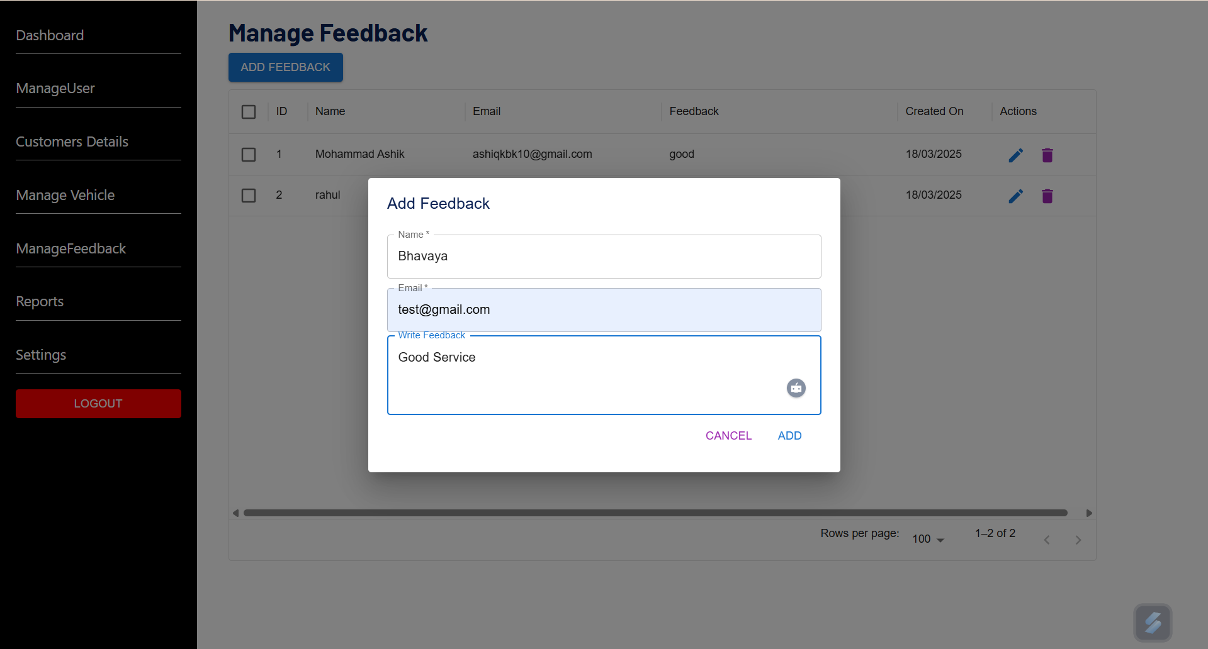
Reports:
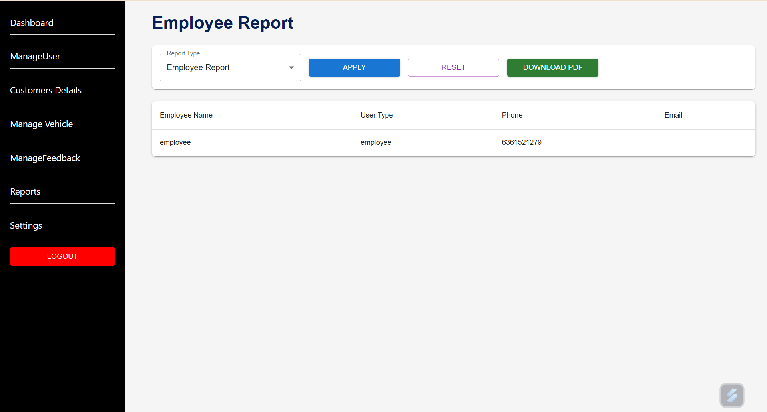

Settings:
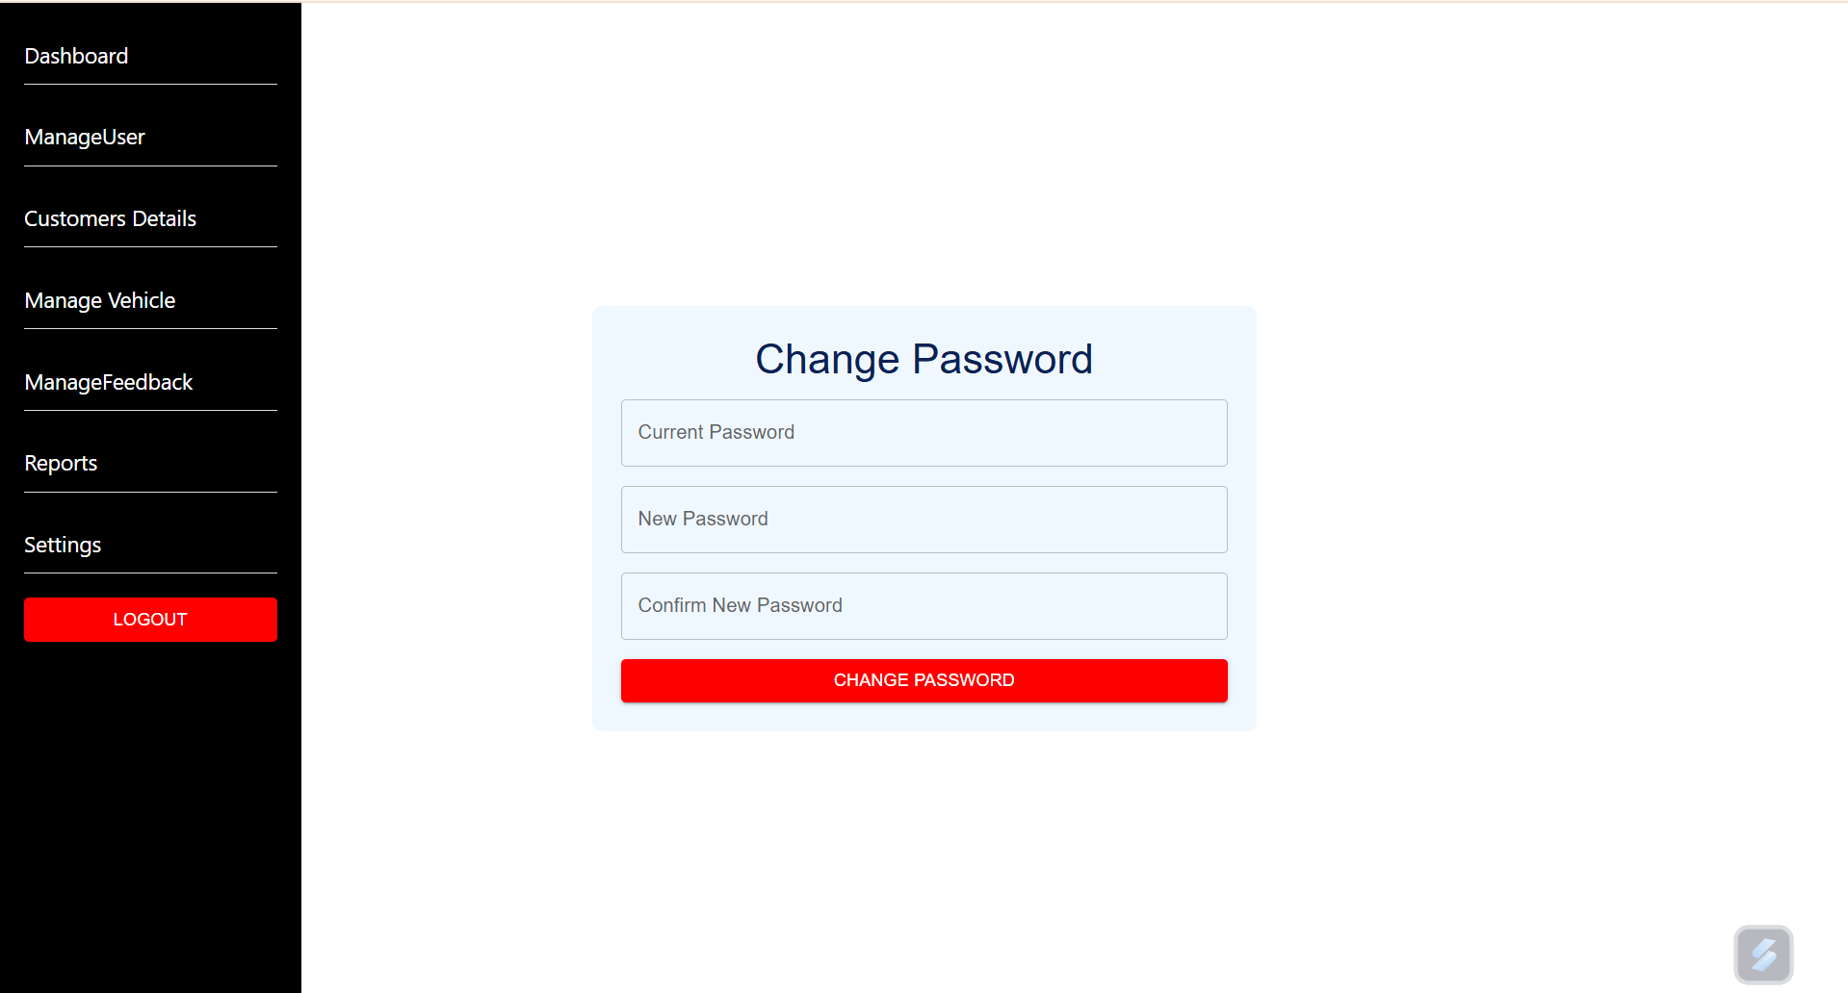

CHAPTER 9
CONCLUSION
I can confidently say that my internship at Accolade Tech Solutions has been a valuable learning experience that helped me improve both my technical skills and professional abilities. I’m especially grateful to the team for their guidance and support throughout this period, which helped me strengthen my frontend development skills using React JS and Material UI.
During the internship, I built a solid understanding of modern web technologies like React JS, Material UI, and JavaScript. I gained hands-on experience in creating user interfaces, building functional components, and managing application states with React Hooks. Integrating MySQL as the backend database also taught me how to handle and organize data for users, orders, and wallet transactions effectively.
Along the way, I got familiar with important development concepts such as API integration, component-based design, and writing clean, modular code. These skills helped me in developing key features like order management, cart systems, wallet recharge functionalities, and user account controls for the system.
Overall, this internship gave me a great glimpse into the professional software development process, far beyond what I had learned in academics alone. I now feel more confident in my ability to build full-fledged web applications and better prepared to take on future challenges in the tech industry. I’m truly thankful for this opportunity and the growth it has brought me.

REFERENCES
[1] https://react.dev/
[2] https://mui.com/material-ui/getting-started/
[3] https://www.w3schools.com/
[4] https://codepen.io/
[5] https://nodejs.org/en

